Period 7 pt. 2
The Great War and the Home Front
Station 1: Suffrage
War and the Fight for Suffrage: Station 1—War and the Fight for Suffrage: Iron Jawed Angels (8 minute scene)
If you were absent—go to my website, period 7 & scroll down to the Iron Jawed Angels
clip.

Station 2: The Great Migration
Art of the Renaissance Jacob Lawrence’s Migration Series

- Read the background on the artist.

Background: Jacob Lawrence was born September 17, 1917, in New Jersey, but was raised primarily in New York City's Harlem. Lawrence moved with his parents to Easton, Pennsylvania, at the age of 2. When his parents separated in 1924, his mother deposited him and his two younger siblings in foster care in Philadelphia, and went to work in New York City. When he was 13, Lawrence joined his mother in Harlem.
Lawrence was introduced to art shortly after his arrival, when his mother enrolled him in Utopia Children’s Center, which had an after-school art program. He dropped out of school at 16 but took classes at the Harlem Art Workshop with Charles Aston and frequently visited the Metropolitan Museum of Art.

In 1937, Lawrence won a scholarship to the American Artists School in New York. When he graduated in 1939, he received funding from the Works Progress Administration Federal Art Project. He had already developed his own style of modernism, and began creating narrative series, painting 30 or more paintings on one subject. He completed his best-known series, Migration of the Negro or simply The Migration Series, in 1941.
Jacob Lawrence was the most widely acclaimed African-American artist of the 20th century. Known for producing narrative collections like the Migration Series and War Series, he brought the African-American experience to life using blacks and browns juxtaposed with vivid colors. He also taught, and spent 15 years as a professor at the University of Washington.
- Watch the slideshow…it’s on a timer. Click on the title page, sit back and watch.

- Answer the questions on your analysis page.

Station 2
Letters from the Great Migration (1917)

Houston, Texas, 4-29-17.

Dear Sir:

I am a constant reader of the "Chicago Defender" and in your last issue I saw a want ad that appealed to me. I am a Negro, age 37, and am an all round foundry man. I am a cone maker by trade having had about 10 years experience at the business, and hold good references from several shops, in which I have been employed. I have worked at various shops and I have always been able to make good. It is hard for a black man to hold a job here, as prejudice is very strong. I have never been discharged on account of dissatisfaction with my work, but I have been "let out" on account of my color. I am a good brassmelter but i prefer core making as it is my trade. I have a family and am anxious to leave here, but have not the means, and as wages are not much here, it is very hard to save enough to get away with. If you know of any firms that are in need of a core maker and whom you think would send me transportation, I would be pleased to be put in touch with them and I assure you that effort would be appreciated. I am a core maker but I am willing to do any honest work. All I want is to get away from here. I am writing you and I believe you can and will help me. If any one will send transportation, I will arrange or agree to have it taken out of my salary untill full amount of fare is paid. I also know of several good fdry. men here who would leave in a minute, if there only was a way arranged for them to leave, and they are men whom I know personally to be experienced men. I hope that you will give this your immediate attention as I am anxious to get busy and be on my way. I am ready to start at any time, and would be pleased to hear something favorable.

New Orleans, La., June 10, 1917.

T-30

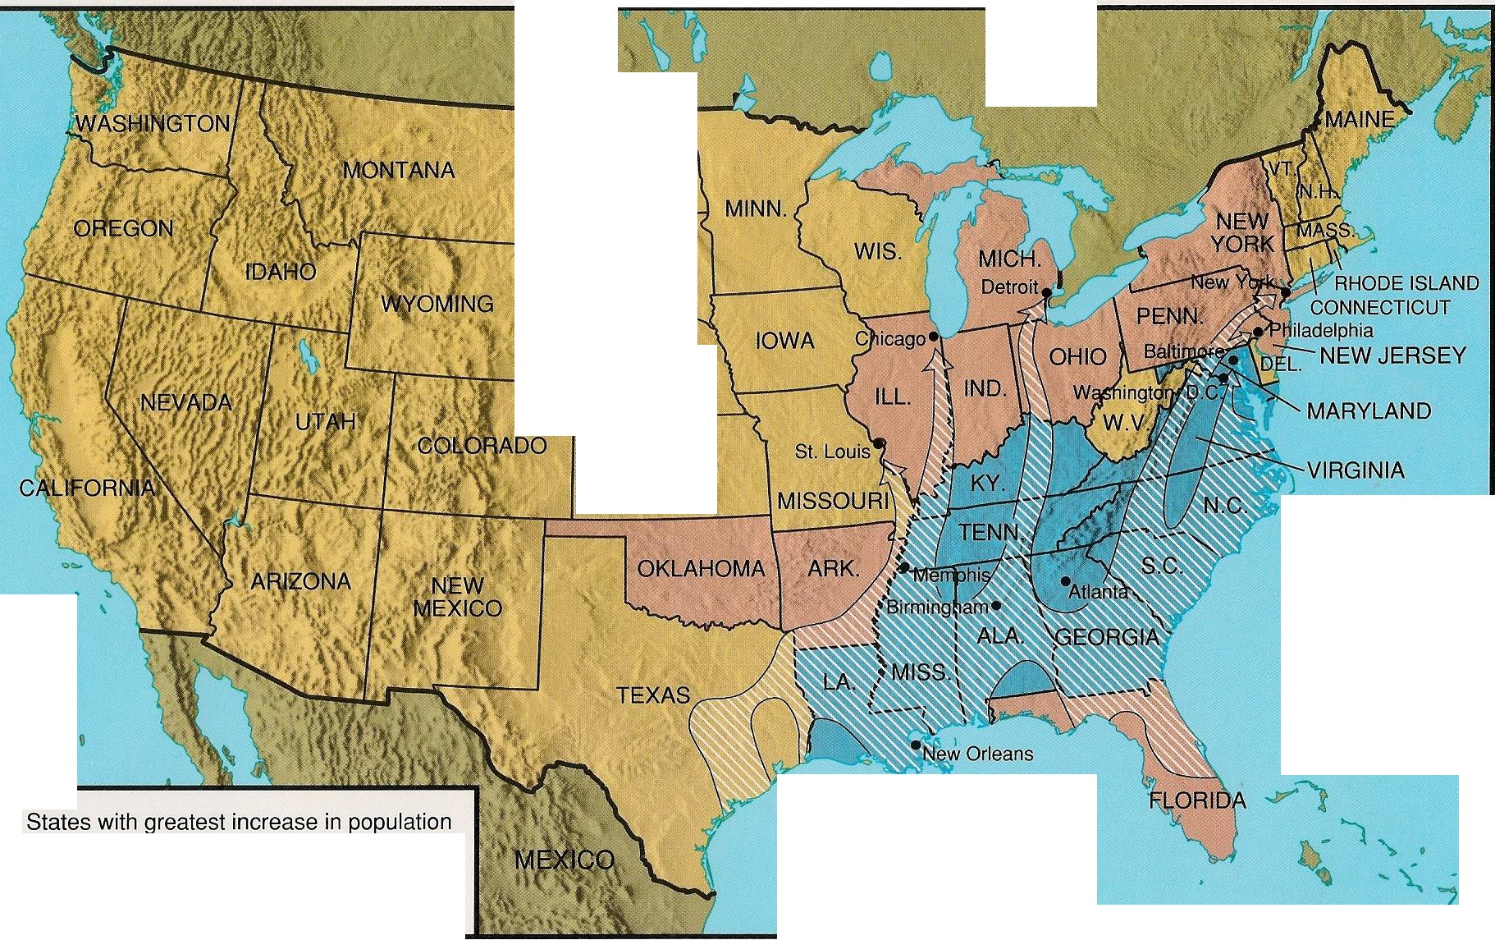
CANADA

NORTH DAKOTA

, SOUTH
- ) DAKOTA NEBRASKA

KANSAS

PACIFIC OCf:AN

D
D States with greatest decrease in population
African-American migration

0 200 400 mites

0 200 400 kilometers
ATLANTIC OCEAN

AFRICAN AMERICAN MIGRATION NORTHWARD, 1910-1920

Thmeassive migration of African Americans from the South to the North during World War I changed the dynamics of race relations in the United States.
© 2001 by Addison-WesleyEducational Publishers Inc.

The Great Migration: The First Wave (1910-1940)
African American Population Growth in the Twenty Cities with the Most African Americans in 1940

Metropolitan Area | 1910 African  American Population | 1940 African  American Population | Difference
New York | 142,100 | 661, 100 | 519,000
Philadelphia | 119,200 | 347,800 | 228,600
Chicago | 58,100 | 346,800 | 288,700
Washington DC | 105,400 | 251,600 | 146,200
Baltimore | 98,400 | 187,100 | 88,700
Detroit | 9 ,000 | 1 68,600 | 1 59,600
S t. Lo u is | 55 ,300 | 1 52,700 | 97 ,40 0
Pittsburgh | 37,600 | 123,300 | 85,700
Cleveland | 10,800 | 88,600 | 77,800
Los Angeles | 6 ,700 | 76 ,200 | 69 ,50 0
Cincinnati | 32,100 | 69,700 | 37,600
Kansas City | 38 ,600 | 68 ,40 0 | 29 ,800
Indianapolis | 24,100 | 56,300 | 32,200
Columbus | 14,700 | 41,500 | 26,800
Boston | 24,300 | 37,700 | 13,400
Dayton | 4,600 | 36,600 | 32,000
Youngstown | 1,000 | 26,800 | 25,800
Buffalo | 2,700 | 24,600 | 21,900
San Francisco/ Oakland | 3,600 | 21,600 | 18,000
Akron | 2,100 | 16,600 | 14,500

