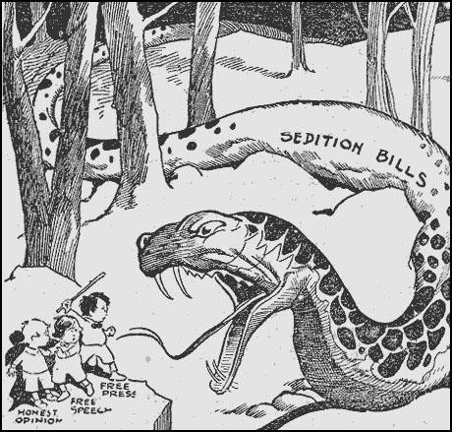
STATION 5: SCHNEK V. US

STATION 5:
MAJORITY OPINION IN SCHENCK V. UNITED STATES – OLIVER WENDELL HOLMES (1919)

The document in question upon its first printed side recited the first section of the Thirteenth Amendment, said that the idea embodied in it was violated by the conscription act and that a conscript is little better than a convict. Of course the document would not have been sent unless it had been intended to have some effect, and we do not see what effect it could be expected to have upon persons subject to the draft except to influence them to obstruct the carrying of it out. But it is said, suppose that that was the tendency of this circular, it is protected by the First Amendment to the Constitution…. We admit that in many places and in ordinary times the defendants in saying all that was said in the circular would have been within their constitutional rights. But the character of every act depends upon the circumstances in which it is done. The most stringent protection of free speech would not protect a man in falsely shouting fire in a theatre and causing a panic. It does not even protect a man from an injunction against uttering words that may have all the effect of force. The question in every case is whether the words used are used in such circumstances and are of such a nature as to create a clear and present danger that they will bring about the substantive evils that Congress has a right to prevent. It is a question of proximity and degree. When a nation is at war many things that might be said in time of peace are such a hindrance to its effort that their utterance will not be endured so long as men fight and that no Court could regard them as protected by any constitutional right.…

STATION 5:

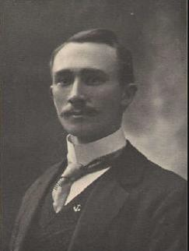
Charles T. Schneck- General secretary of the U.S. Socialist Party
Printed and distributed 15,000 anti-draft leaflets urging male citizens to not register for the draft.
His argument was that the draft (Conscription), constituted as involuntary servitude, which is prohibited by the 13th Amendment, additionally he calimed his actions were protected by the 1st amendment.

He was arrested in and convicted for violations of the Espionage Act, which made it a crime to willfully cause or abstruct the draft effort.

The Constitutional Issue:did the Espionage Act violate the 1st amendment protection of freedom of speech?

Decision: Court ruled the Espionage Act was constitutional

Free speech was not an absolute right
Civil liberties may be limited during times of war

