Station 4: Propaganda Posters
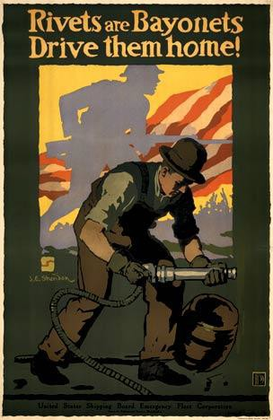

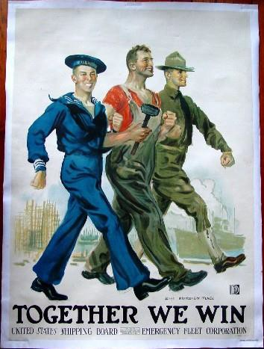
5 6 7

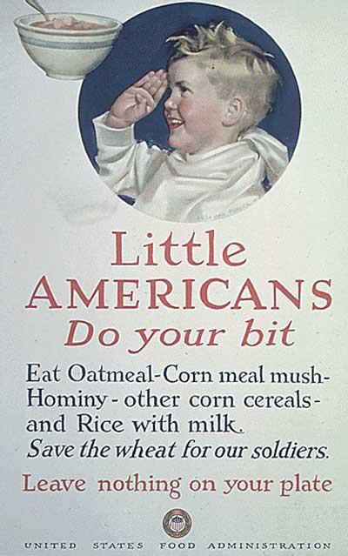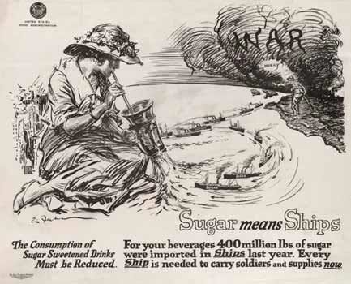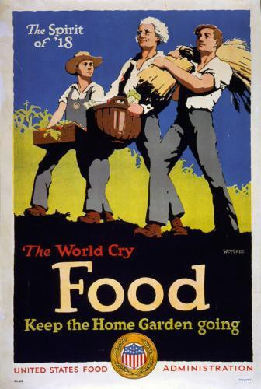

8 10
- In “War” cloud the word “Hurry!” appears
- Ships going towards war say: supplies, arms, soldiers, weapons, food
- Ships going toward the woman say: sugar
9

