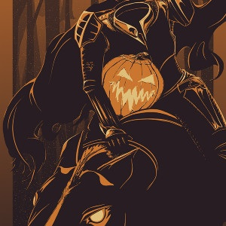
“The Legend of Sleepy Hollow” Activities

Handout
Complete the plot diagram for the story.
Daybook
- Create a T-chart of all of Ichabod Crane’s likes and dislikes.
- When you finish your reading, do you think that Ichabod Crane will win Katrina’s heart? Explain with specific references to the story.
Comprehension Questions: Answer as you read on a separate sheet of paper.
- What mood does the setting of this story create?
- Who do the villagers believe the headless horseman is? How did he lose his head?
- What is Ichabod Crane’s job? What other job did he do to earn a little more money?
- Where does Ichabod Crane live? Why does he need to be able to have all of his belongings in a small bundle?
- Why do the women in the countryside think he is an important person? How do the mothers treat him as a result? How do the younger girls respond to him?
- What subject does Ichabod like to read about? What has increased his interest in this subject?
- What would happen to Ichabod when he would walk home at night after spending the afternoon reading? How would he handle that?
- What are the two main things that Katrina Van Tassel is known for? What different things does she wear that demonstrate each of these?
- The author, Washington Irving says, “When he entered the house, the conquest of his heart was complete.” What does the rest of that paragraph tell us about why Ichabod liked Katrina?
- What two things make it difficult for Ichabod to fulfill his goal of marrying Katrina?
- What gives Ichabod an excuse to visit Katrina at her house?
- What approach does Brom Bones (Brom Van Brunt) want to take when he discovers Ichabod is interested in Katrina? Why can’t he do that?
- What are two things Brom Bones does to get back at Ichabod for trying to steal Katrina?
- Ichabod takes great care in his appearance as he gets ready for the party at Baltus Van Tassel’s. What is funny about the horse he is riding as he starts off like a “knight in quest of adventures”?
- How is Brom Bone’s horse, Daredevil, similar to him in its appearance and actions?
- What story is told about Brouwer’s encounter with the headless horseman?
- What story does Brom Bones tell about his encounter with the headless horseman?
- How do we know that Katrina turned Ichabod down at the party?
- What logical explanation is there for three of the things Ichabod sees or hears when he is near the old, large tree?
- What happens when Ichabod tries to get across the bridge?
- When Ichabod sees something huge and black by the brook, why doesn’t he turn and run away? What two things does he do instead?
- What happens when Ichabod slows down or speeds up in an attempt to get away from the dark horse and its rider? What does Ichabod see that makes him so terrified that he sends his horse into full flight?
- Instead of following the road to Sleepy Hollow, where does Gunpowder go? What makes it even harder for Ichabod to hold onto his run-away horse?
- What four traces of the chase do the searchers find the next day?
- When news of Ichabod is reported years later, what do we learn about why he left?
- What makes it seem that Brom Bones knew something about what happened that night?

