

Hello and welcome to 1st Grade! My name is Mrs. Pierce. I will be your first-grade teacher. We are going to have a great year together, so get ready to learn, laugh, and grow. Before school begins, I want to share a little about myself.
I was born and raised in Knoxville, TN and enjoy being in the East TN area. I went to school at ETSU where I received my bachelor and masters in Elementary Education. While studying at ETSU I was a pole vaulter on the ETSU track and field team where I jumped my best height of 3.95m (12ft 11 in). I still currently hold the indoor record at ETSU. I also met my husband, Desmond, on the track team where he ran cross country and the 800. He also current works at ETSU in Annual Giving.
Desmond and I have been married for 6 years and have a one year old, Oakley. After graduating, we lived in Bristol for two years before moving to Nashville. I taught 1st grade in Nashville for 3 years before we moved to Pittsburgh, PA, where I taught Pre-K. When we found out we were pregnant we wanted to move home to be closer to family. This past school year I worked as an interventionist at South Central.
A few of my outside of teaching hobbies include running/ walking at Warrior’s Park or the Tweetsie Trail, reading for fun, binge watching Netflix shows, and playing with Oakley. I am very excited for the 2024 Summer Olympics and will be watching my favorite sports such as track & field and gymnastics. I cannot wait to get to know all about you and your hobbies at the beginning of the school year!

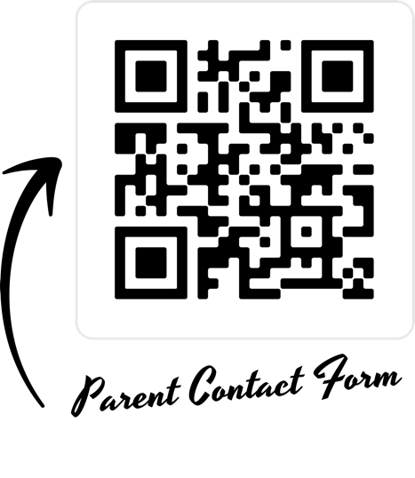
Sincerely,

Mrs. Pierce

