**This tutorial will show you the steps to**

**create this simple Florist Flyer using Microsoft Word.**

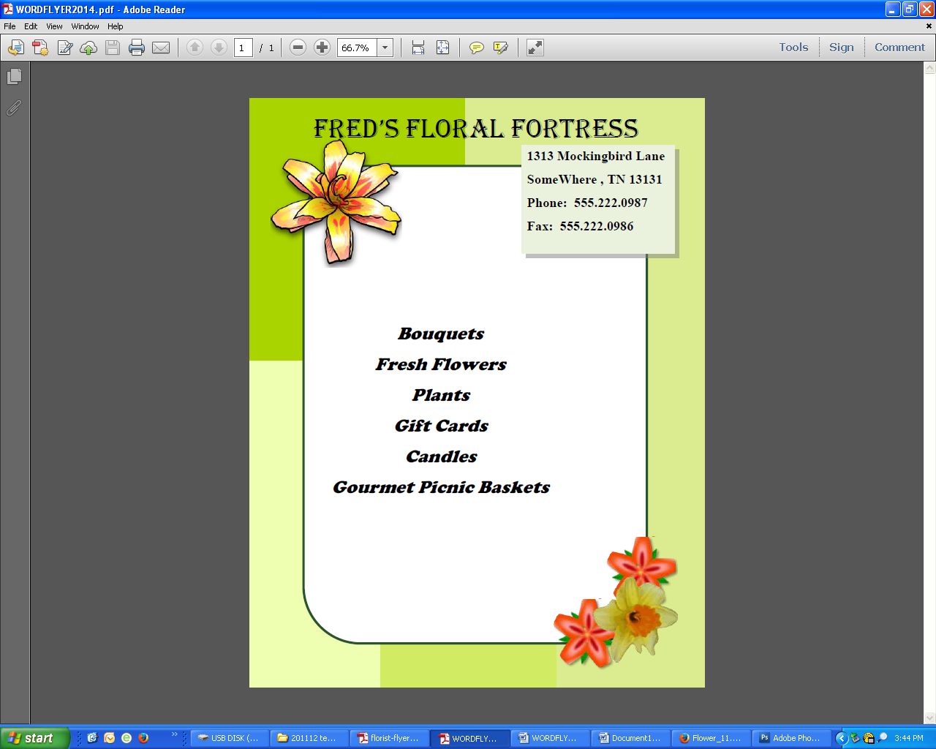

**\*\*\* You will find the flower images on my web page.**

1. To begin, go to the **Ribbon** and select the **Page Layout Tab**. Click on **Size** and select **Letter** from the drop down menu
2. Click on **Margins** and select **Narrow** from the drop down menu.
3. **Page Orientation --** Go to the **Page Setup Group** and click on **Orientation**. Select **Portrait** from the drop down menu.
4. **Insert Rectangles ---** We will construct the colored background with 4 rectangles. Go back to the **Ribbon** and select the **Insert Tab**. Go to the **Illustrations Group**. Select **Shapes** to open up the Shapes window .
5. Select the Rectangle under **Recently Used Shapes**
6. Once you have drawn the first Rectangle, you will notice that the **Ribbon** has changed to the **Format Tab** which showcases the **Drawing Tools**. To continue drawing the remaining rectangles, just select the **Rectangle Tool** from the **Insert Shapes Group** on the **Format Tab**. Draw the rectangles on the page so that they look like this:
7. **Shape Fill --** Now we will add color to the rectangles. Select Rectangle 1. Then select **Shape Fill** from the **Shape Styles Group** on the **Format Tab**.
8. **More Fill Colors** Select **More Fill Colors** from the **Colors Menu** that appears. Then select the **Custom Tab** in the **Colors Window**.
9. **Fill Rectangle 1 --** Set **R** to "170", **G** to "212" and **B** to "0". Click **OK**.
10. **Fill Rectangle 2 --** In Rectangle 2: Set **R** to "218", **G** to "236" and **B** to "143". Click **OK**.
11. **Fill Rectangle 3 --** In Rectangle 3: Set **R** to "239", **G** to "255" and **B** to "177". Click **OK**.
12. **Fill Rectangle 4 --** In Rectangle 4: Set **R** to "209", **G** to "236" and **B** to "99". Click **OK**
13. **Remove Outlines** While holding down the **"Shift"** key select all 4 Rectangles. Then go back to the **Format Tab** and select **Shape Outline**. Then select **No Outline** from the menu that appears.
14. The new background should look like this:
15. **Rounded Rectangle** Go back to **Shapes** and select the 6th Icon in **Recently Used Shapes**. Draw the Rectangle. You will notice on the right side of it there is a **Yellow Diamond**. Click on it and drag to change the radius of the Rounded Corners. Release when you have the desired look. Set the **Fill** to "White" and the **Stroke** to a "Dark Green".
16. Go back to the **Ribbon** and select the **Insert Tab**. Then go to the **Text Group** and select **Text Box**.
17. **Insert Text Box** Choose **Simple Text Box** from the drop down menu which will put a ready made Text Box into your document, or select **Draw Text Box** to create your own. You will also notice that the **Ribbon** has changed to the **Format Tab** which showcases the **Text Box Tools**. Start typing the Company Title which is:"FRED’S FLORAL FORTRESS".
18. **Edit Font** Go back to the **Home Tab** and go to the **Font Group**. Select the down arrow next to "Calibri". In this case the **Font Family** is "Harlow Solid Italic" and the **Font Size** is "48".
19. **Format Text Box --** Select the **Text Box**. While holding the mouse directly over the **Text Box Outline**, right click and select **Format Text Box** from the menu that appears.
20. This will open the **Format Text Box Window**
21. In the **Fill Section**, set **Transparency** to 100% and in the **Line Section** you can set **Color** to **"No Color"**. Then click **OK**.
22. **Add New Text --** Next add the company address - "1313 Mockingbird Lane, Somewhere, TN 13131, Tel. 555.222.0987, Fax 555.222.0986". Create a new **Text Box** for each block of Text.
23. Go to the **Paragraph Group** and select the **Center Icon** . Then select the **Line and Spacing Icon** and choose **"Line Spacing Options"** from the drop down menu.
24. **Line Spacing** This will bring up the **Paragraph Window**. Go to the **Spacing Section**, select the down arrow under **Line Spacing**, choose **"Exactly"**. Set **"At"** to 20pt. Change **"After"** to "6pt". Click **OK**.
25. **Repeat Transparency** Adjust the **Transparency** of all **Text Boxes** to "100%" and remove all **Text Box Outlines**.
26. **Add Images --** Add images of 3 flowers . ***Word*** as long as you first place the Image within a Text Box. Place a **Text Box** on the page. Then go to the **Insert Tab** and click on the **Picture Icon** in the **Illustrations Group**.
27. **Insert From File** This allows you to insert a **Picture from File**. It opens up the **Insert Picture Window**, where you can select your file and then click **Insert**
28. **Scale Image** Once the Yellow Flower has been inserted we will need to scale it.
29. Place them where you would like. Add anything else that you feel is needed to complete the flyer.
30. **Your finished flyer should look something like the flyer below.**
31. **Save your final flyer for a grade.**

