Reverting to an earlier upgrade:
- Click on the red button Free Java Download at www.java.com.
- Not the right operating system? See all Java downloads here. – click here
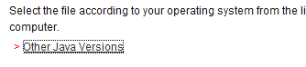

- Select Other Java Versions

- Then click on ‘Archive Java Technology Products Download.
- Older versions:
You can obtain the older versions of Java and related documentation from the link below:
Archive Java Technology Products Download
- Select from the drop down box 6 update 13.
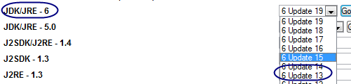

- Then click go. Select R=JRE 6u13 – download JRE

- Select your platform – Windows – agree to the terms and click continue, click on Windows Offline Installation
jre-6u13-windows-i586-p.exe

This should set you up with 6_13

